The Cross: dealing with the problem of sin
Townfield 24.9.23

This service is part of our ‘Rooted’ series – an opportunity to go back to the roots of our faith, remembering the important foundations that our life with God is built on. The aim of these services is to listen a bit, and then to talk with each other, to learn from each other.

What have you found helpful about the way that the cross has been explained to you in the past?
- Is there anything you have found difficult or confusing about the way that the cross has been explained to you?

Let’s begin by reading Philippians 2.1-11.

This reading sees Jesus’ life & attitude as an example for us to follow. What qualities of Jesus can you see here which are good for us to follow (verses 6-11)?

These verses (which lots of experts think might be one of the very first Christian hymns, which is then quoted in this letter to the Christians in Philippi) highlight that Jesus willingly chose the path of sacrifice that led to the cross.
- Why do you think it’s important to remember this when we think about the cross?
  - Does it help to answer the criticism that is sometimes made, that the cross makes God seem to be cruel (verse 6 is worth remembering here too – that Jesus is described as ‘being in very nature God’, meaning that Jesus on the cross is God willingly sacrificing himself)?

Countless experts have used very long words, in very heavy books, to try and explain the meaning of the cross. We won’t get to the bottom of all that thinking today, but in the service we very briefly looked at 3 readings which gave slightly different perspectives on the cross. All the perspectives build together to give us a fuller understanding of what Jesus did.

Do any of these readings stand out to you, or make you want to talk things through more together?

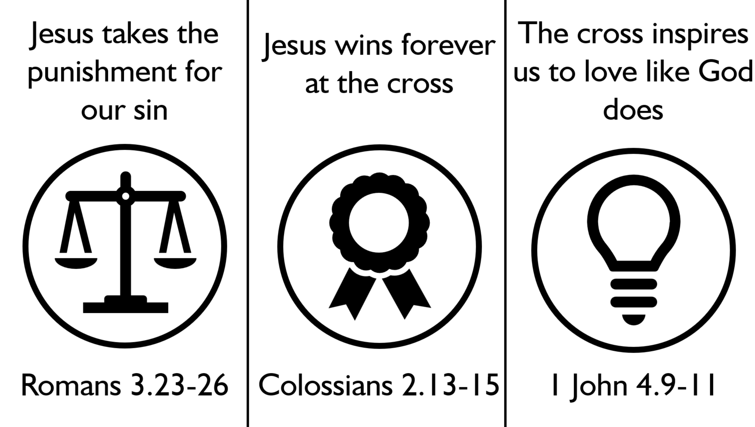

It would be very easy to stay with theory when we talk about the meaning of the cross. What difference do you believe that the cross has made to you?

